Facebook and Fake News

Consider each of the below proposals, and fill in each of the below TODOs.

# Proposals

## Proposal 1

Facebook relies on an algorithm as well as individual users’ reports to identify content that is potentially "fake news." Once the content has been identified, it is sent to third party fact-checkers for verification. If the content is verified as fake news, it is publicly flagged with a warning that the content is disputed by fact-checkers.

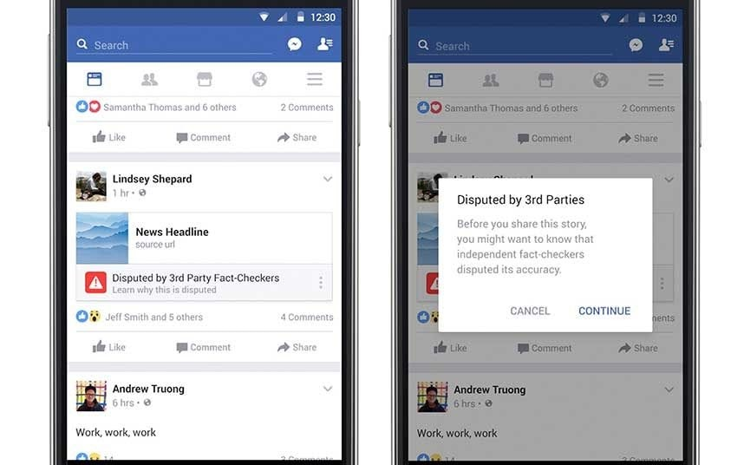

## Proposal 2

However, a designer at Facebook believes that there needs to be a different approach to content regulation. Their proposal is that content deemed problematic by third-party fact-checkers should be prevented from being shared on the platform altogether.

# 

# Questions

1. Which form of content regulation, Proposal 1 or Proposal 2, do you feel is better? Why?
   1. I feel Proposal 2 is better. If Facebook is serious about content regulation, they should simply remove content that does not fit their community standards and strongly justify those removals. While many consider social media companies to be platforms and not publishers, there is in fact no actual difference between the two and by accepting their power to regulate content, Facebook has acknowledged its editorial control.
2. Which form of content regulation, Proposal 1 or Proposal 2, do you think best preserves or promotes the [five rights and opportunities necessary for a democratic public sphere](https://cs50.harvard.edu/college/2020/fall/labs/10/lecture/#five-rights-and-opportunities-for-a-democratic-public-sphere)?
   1. Which proposal best preserves or promotes Rights? Why?
      1. Perhaps counterintuitively, Proposal 2 best preserves and promotes pro-democratic rights. By delineating conditions for association with the Facebook corporation and (by extension) the Facebook community, all participants are provided a clear understanding of their rights and responsibilities to their fellow community members
   2. Which proposal best preserves or promotes Opportunity for Expression? Why?
      1. Proposal 2 promotes expression by allowing all members of the community to engage in actual discussion with each other. Lies and misinformation crowd out other forms of expression and promote whirlpools of discourse that sink all those who enter.
   3. Which proposal best preserves or promotes Access? Why?
      1. Neither proposal has any effect on access to the Facebook community. Access is gained simply by registering on the platform and accepting its terms. Nor is it the case that participation on Facebook is required to participate in public matters.
   4. Which proposal best preserves or promotes Diversity? Why?
      1. Proposal 2 preserves diversity, as lies and deliberate misinformation are not “competing views” by any common understanding of the term, nor do they contribute to a more informed or reasoned position.
   5. Which proposal best preserves or promotes Communicative Power? Why?
      1. Proposal 2 promotes the communicative power to challenge the mainstream view by creating space for well-justified, persuasive opposition to common beliefs. If Facebook allowed lies and deliberate misinformation on their platform, they would be undermining the ability of citizens to find legitimate challenges to the mainstream view.